Autism Alliance ‘Breaking Point’ Campaign Pack

Background to the campaign
- New research commissioned by the Autism Alliance shows that thousands of autistic adults across England are not receiving the social care they need, preventing them from living well and actively in their communities, and from taking up work. A lack of care also means that too many autistic adults reach crisis point, leading to family breakdown and confinement in mental health hospitals.
- There is a gap in specialist social care for autistic adults – most likely those with a moderate learning disability, and most likely in domiciliary care. Alongside this, there is likely to be an even larger gap in specialist community-based support (eg. local peer support groups, advocacy) for autistic adults without a learning disability or with a mild learning disability.
- Although many autistic adults meet the eligibility criteria in the Care Act 2014, they are still denied the care they need, and have to fight at every stage of the process. The law is effectively being broken every day across England. This is because of long term Government underinvestment in the adult social care sector and its workforce, together with a range of other barriers in the system, including a lack of autism acceptance and understanding, and a focus on responding to crisis rather than maintaining wellbeing. Building the Right Support, and other actions to increase access to the right care, are not working.
- This campaign highlights the profound consequences of the crisis in social care for autistic adults and their families in England, and calls for Government to act by:
  - Investing additional funding to close the gap in care for autistic adults in England, recognising the unacceptable outcomes they face, and also the economic benefits of providing the right support. This would represent between 0.4% and 0.7% of total adult social care spending in England, together with the cost of specialist workforce recruitment, retention and training, and could be paid for by addressing inefficiencies in current spending across health and care.
  - Engaging with wider reform of adult social care, using the experiences of autistic adults and their families as a guide to better care for everyone: and as part of this, quantifying and addressing the larger gap in specialist community-based support for autistic people and their families.
- The campaign also calls on local authorities and NHS services (and the Care Quality Commission) to work in partnership with care providers, autistic people and their families to address the barriers that prevent access to specialist care for autistic adults.

Key campaign messages
- Over 10,000 autistic adults in England are not getting the social care they need, leaving them unable to live well and actively in their communities and unable to take up employment. For this group, this is most likely to be care provided in the home, but could also be residential care or supported living.

- Over three quarters (77%) of autistic adults reach crisis point before care is provided, resulting in family breakdown and for some, confinement in mental health hospitals where they face restraint, medication and trauma.

- The Care Act 2014 is clear that adults with eligible needs should get care, so the law is being broken daily across England. This is because of long term underinvestment in social care by the Government. There is not enough money in the system to meet demand.

- Autistic adults face a double disadvantage. They already experience huge inequalities in life expectancy, health and quality of life, and these are reinforced by the crisis in care.

- This has to change. Government could close the gap in care by investing less than 1% of the total adult social care budget in England, creating significant economic benefits and reducing expenditure on long-term confinement in mental health hospitals. This could be paid for by addressing inefficiencies in current spending across health and care.

- But this has to be part of wider reform of social care so that specialist care providers are better supported and can work with local councils to meet demand. The reforms that would improve social care for autistic people would lead to better care for everyone.

Secondary points
- Autistic adults and their families have a poor experience of the social care system: they wait years for a care assessment, they don’t receive enough support through the process, and even if care is provided, often it doesn’t meet their needs.

- We know what reform is needed: there is strong consensus amongst local authorities, care providers, autistic adults and their families.

- Throughout the system, we need to see acceptance and understanding of autism, and co-production with autistic people and their families to design packages of care and support that reflect their individual needs, interests and experiences.

- Social care isn’t just about people in later life – it’s vital for large numbers of working age adults, particularly autistic adults and adults with a learning disability.

Campaign evidence
The campaign is based on:
- New evidence collected by the Autism Alliance from autistic adults and their families.
- New analysis carried out by Cordis Bright estimating, for the first time, the size of the gap in specialist social care for autistic adults in England, and which specific group of autistic people this is likely to affect. (Cordis Bright works with the Association of Directors of Adult Social Services to deliver key data and insight exercises including the ADASS Spring Survey.)
- New evidence collected by Cordis Bright on behalf of the Autism Alliance from local authorities and care providers.

This evidence was collected in summer/autumn 2023, and includes:
- A survey of autistic adults and parents/carers, completed by 232 people (128 autistic adults, 104 parents/carers).
- A survey of English local authority commissioners, completed by 33 commissioning leads focusing on learning disability and autism.
- A survey of specialist care providers delivering social care services for autistic adults, completed by 99 providers.
- Interviews with 6 English local authority commissioners and 12 specialist care providers.

The data from these exercises shows that:
- Over 10,000 autistic adults in England are not receiving the social care they need, most likely autistic adults with a moderate learning disability.
- The cost of closing this gap would be between £70 million and £140 million, which represents between 0.4% and 0.7% of total spending on adult social care in England.
- There is likely to be an even bigger gap in specialist community-based support for autistic adults and their families. This is not regulated social care, but includes local peer support groups, advocacy, and information and advice.
- 77% of autistic adults reach crisis point before care and support is provided.
- 48% of autistic adults receiving social care say it does not meet their needs.
- 44% of autistic adults wait more than 2 years for care and support to be provided.
- 58% of autistic adults receive poor support during the process of trying to get social care.
- 56% of autistic adults don’t try to get care and support because they don’t think they’ll get it.

Other relevant data:
- Total annual Government spending on adult social care in England: £19 billion.
- Estimated total gap in adult social care funding: £7 billion to £14 billion.
- Stark inequalities faced by autistic people:
  - Autistic people’s life expectancy is on average 16 years lower than the general population. (Hirvikoski, Tatja, Ellenor Mittendorfer-Rutz, Marcus Boman, Henrik Larsson, Paul Lichtenstein, and Sven Bölte. ‘Premature Mortality in Autism Spectrum Disorder’. The British Journal of Psychiatry 208, no. 3 (March 2016): 232–38.)
  - Autistic adults without a learning disability are 9 times more likely to die from suicide. (Ibid.)
  - Currently, 1,335 autistic adults are confined in mental health hospitals in England. (Assuring Transformation Dataset, NHS Digital, October 2023.)

Campaign assets
The campaign is supported by two main assets: a campaign report and a research report.

Campaign report
This highlights the profound consequences of the failure of social care for autistic adults and their families in England, and hears their voices directly: both their experiences of the social care system, and their views on the reforms that are needed. The campaign report also summarises the headlines from the new evidence presented in the research report from Cordis Bright.

Research report (from Cordis Bright)
- Estimates the size of the gap in social care for autistic adults in England, and the cost of closing the gap. The calculation uses Short and Long Term (SALT) data on adult social care collected by the Department for Health and Social Care together with data on the prevalence of autism and learning disability, and draws on research about the incidence of autism amongst people with a learning disability, and the proportion of people with different types of learning disability. All research and data sources are referenced in the report.
- Identifies additional barriers that prevent access to specialist social care for autistic adults in England, and a set of enablers which would address these barriers through action from local authorities, the NHS and the CQC. The report presents evidence from local authorities and care providers which identified these barriers and enablers.
- The research report was commissioned from Cordis Bright by the Autism Alliance, reflecting Cordis Bright’s recognised national work with the Association of Directors of Adult Social Services, and their recent analysis of the financial pressure on specialist charities supporting autistic people and people with a learning disability.

Objectives of the campaign
The campaign aims to:
- Reach the heart of Government with its message and new data and evidence. The Autism Alliance will send, jointly with campaign supporters, an open letter to the Prime Minister and Secretary of State for Health and Social Care, asking them to commit to investment and reform in social care, led by the voices of autistic people.
- Secure the support of Parliamentarians – including the All-Party Parliamentary Group for Autism, other relevant Parliamentary Committees, and other key political figures (eg. Metro Mayors in England), asking them to make representation to the Government.
- Reach party leaders and manifesto leads across the main political parties in England in advance of the next General Election, encouraging them to prioritise social care reform and better outcomes for autistic people in their Manifestos.
- Reach political leaders in other parts of the UK – although the research relates to England, the issues identified and the reforms required will be relevant across Scotland, Wales and Northern Ireland. The Autism Alliance will work with charities in other parts of the UK to share the campaign evidence and messages with relevant political leaders.

How you can support the campaign
You can support the campaign by:
- Sharing the campaign report and new research on social media. Suggested social media posts, with graphics to use, are set out below.
- Supporting campaign activity on social media using the #BreakingPointCampaign hashtag, resharing posts from the Autism Alliance and from other organisations supporting the campaign. These may include articles in the mainstream and specialist press, blogs, and video resources.
- Writing to your MP and/or Metro Mayor in England to draw attention to the unacceptable failure of social care for autistic adults, share the campaign report and new research, and ask them to write to the Prime Minister and Secretary of State for Health and Social Care.
- Signing up as a supporter of Real Change for autistic people and their families. Join the wider group of organisations and people calling for systemic reform to address the unacceptable inequalities autistic people face across services and society.

You can also support the campaign by helping us find more autistic adults and their families who would like to share their stories. If you would like to explore sharing your story publicly and in the media, or know someone who may be prepared to share their experiences, you can contact the Autism Alliance at: hello@autismalliance.org.uk. We will be in touch and may be able to feature the story as part of the campaign.

Suggested social media posts

Join the call, share the report and new research

X/Twitter posts
Over 10,000 autistic adults aren't getting the social care they need, leaving them unable to live well in their communities & take up employment.
The Govt needs to close the gap in care, as part of wider reform.
Read the new report: https://www.autism-alliance.org.uk/breaking-point
#BreakingPointCampaign

Autistic adults are at breaking point, denied the social care they need because of long term Government underfunding.
The @Autism_Alliance is campaigning for change – for autistic adults, and for everyone.
Support the call: https://www.autism-alliance.org.uk/breaking-point
#BreakingPointCampaign

Over 75% of autistic adults reach crisis point because they can’t access specialist social care.
The human cost of this failure is unacceptable.
Support the @Autism_Alliance #BreakingPointCampaign calling for Government to act:
https://www.autism-alliance.org.uk/breaking-point

Autistic adults face a double disadvantage because of the social care crisis. Already facing unacceptable inequality, a lack of care leads many to reach breaking point.
Government must act now – read more in @Autism_Alliance #BreakingPointCampaign report:
https://www.autism-alliance.org.uk/breaking-point

The Care Act 2014 is clear that adults with eligible needs for care should get care, but autistic adults are often excluded due to Government underinvestment.
The law is being broken daily across the country.
Join call for change: #BreakingPointCampaign https://www.autism-alliance.org.uk/breaking-point

Over 1,300 autistic people are currently detained in mental health hospitals, when they could be living well & actively in their communities.
The Government can change this by finally engaging with reform of adult social care.
See #BreakingPointCampaign: https://www.autism-alliance.org.uk/breaking-point

Social care is failing autistic adults.
Improving care for them can help improve care for everyone.
The Government needs to act, once and for all, to provide investment and lead reform of the care system in England.
Join the #BreakingPointCampaign at:
https://www.autism-alliance.org.uk/breaking-point

LinkedIn post
The Autism Alliance is drawing attention to the failure of the social care system for autistic adults in England. There are around 1 million autistic people in the UK, and the majority are adults.
Autistic people face some of the greatest inequalities of any group. Their life expectancy is on average 16 years lower than the rest of the population, and autistic adults without a learning disability are 9 times more likely to die from suicide.
Adult social care plays an essential role in helping autistic people live happier, healthier, more fulfilled lives. Specialist care providers that understand autism and use person-centred approaches can help autistic adults live well and actively in their communities, take up work, and prevent the escalation of need.
But the social care system is underfunded, and new research from the Autism Alliance shows that over 10,000 autistic adults in England are not getting the social care they need. Tragically, over three quarters reach crisis point without care, leading to family breakdown and for some, admission to mental health hospitals, where they can face excessive restraint, medication and the risk of abuse.
The Care Act 2014 is clear that people with an eligible need for social care should receive that care, but the law is being broken daily across the country because of a lack of Government investment. Autistic adults and their families are being pushed to breaking point.
The @Autism Alliance’s Breaking Point report amplifies the voices of autistic adults and parents/carers who have had to fight at every stage for access to care. People like Elliot Dodds (aged 28), whose sister, Beckii Davis (aged 30), spent more than four years campaigning for him to be released from long-term segregation in hospital after he suffered a mental health crisis. Elliot also has epilepsy and a moderate learning disability.
“We thought he’d be in and out…but it was more than four years until he came home,” she said.
“Mum repeatedly said she would be happy for him to come and live back at home, with support, but the request was continuously blocked.”
The human cost of this failure is unacceptable. Government needs to close the gap in care so that autistic adults can be supported to live well and actively in their communities. This will need investment, but it is a fraction of the national budget for adult social care and could be paid for by addressing inefficiencies in current spending across health and care. Closing the gap will also need reform, to address the other barriers autistic adults face in accessing care – but crucially, the reforms that would improve social care for autistic people would improve care for everyone.
There is also a strong economic case for Government to act. Providing the care that allows autistic adults to thrive and live in their communities, increases productivity through employment and reduces reliance on higher cost long-term inpatient mental health facilities.
If you believe in this cause, join the campaign and add your voice. You can also write to your MP and share the report and new research, using the campaign pack at https://www.autism-alliance.org.uk/breaking-point
#BreakingPointCampaign

Social media graphics
Available for both X/Twitter and LinkedIn.

Image 1:
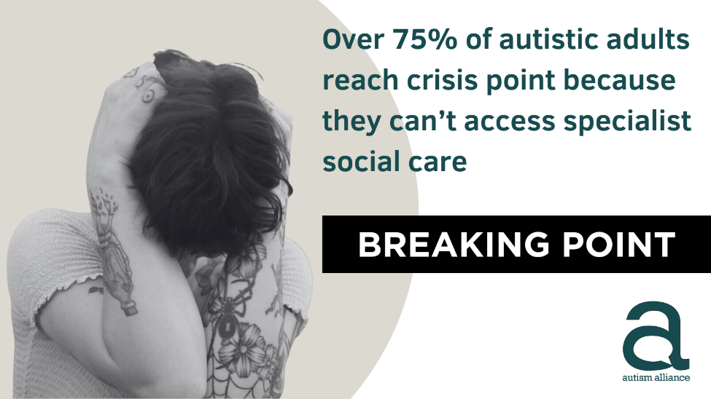

Image 2: Image 3:
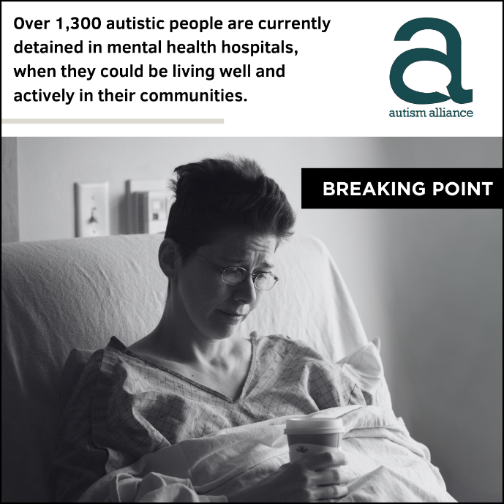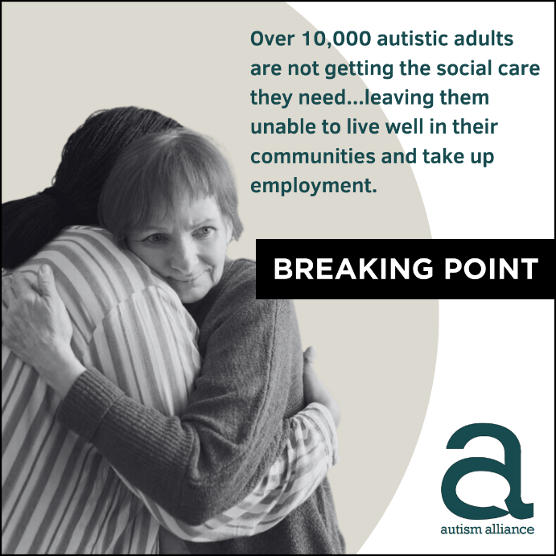

Template letter to write to your MP

Find out who your MP is by entering your postcode at: www.theyworkforyou.com

Subject: The law is being broken every day in England

Dear [name]
I am writing to draw your attention to an unacceptable situation where some of the most disadvantaged people in our society are being let down, prevented from thriving and from contributing to our society, and where the law is being broken every day.
The Autism Alliance’s new report, Breaking Point, exposes the profound implications of the social care crisis for autistic people and their families, and the double disadvantage autistic people face in the social care system.
It includes new research as well as testimony from autistic adults and their parents and carers. This includes Beckii Davis (aged 30), who spent more than four years campaigning for her autistic brother Elliot Dodds, (aged 28), to be released from long-term segregation in hospital after he suffered a mental health crisis. Elliot also has epilepsy and a moderate learning disability.
“We thought he’d be in and out…but it was more than four years until he came home,” she said.
“Mum repeatedly said she would be happy for him to come and live back at home, with support, but the request was continuously blocked.”
The report also shows that there is strong consensus on the reforms required to increase access to specialist care and support for autistic people, amongst local authorities, care providers, and autistic adults and their families.

What do you really know about autistic people?
In the UK, around 1 million people are autistic. Contrary to popular perception, the majority are adults; and 4 in 10 autistic people have a learning disability.
Autistic people have significant strengths, including:
- attention to detail,
- focus and information processing,
- and can be active participants in their community and in employment.
However, they still face some of the greatest inequalities of any group in society.
Compared to the rest of the population:
- their life expectancy is 16 years lower;
- and autistic adults without a learning disability are 9 times more likely to die from suicide.

What helps autistic people live happier, healthier, more fulfilled lives?
Adult social care plays an essential role in helping autistic people live happier, healthier, more fulfilled lives.
Specialist care providers that understand autism and use person-centred approaches can help autistic adults live well and actively in their communities, enter employment, and prevent the escalation of need that too frequently leads to crisis.
This can range from specialist care in the home or supported living to peer-led support groups and local advocacy services.

Why are autistic people at breaking point?
Across England, autistic adults face a double disadvantage.
They are being failed by the social care system which, starved of investment, cannot meet demand for specialist social care. The implications for autistic people and their families are profound. Already faced with stark inequalities, which are magnified because of a lack of care and support, too many face a deterioration in mental health which can lead to crisis.
New research from the Autism Alliance shows that:
- Over three quarters (77%) of autistic adults reach crisis point while waiting for care, leading to family breakdown and for some, confinement in mental health hospitals, where they face restraint, medication and trauma.
- Over 10,000 autistic adults with a moderate learning disability are not getting the social care they need (such as care in the home or supported living), leaving them unable to live well and actively in their communities and unable to take up employment.
- 44% of autistic adults wait more than 2 years for any action to be taken to provide care, and almost half (48%) say that even where care is provided, it does not meet their needs.
This is in direct contravention of the Care Act 2014, which is clear that people with eligible needs for care should receive care, and that local authorities should promote wellbeing and reduce or prevent the escalation of need. The law is being broken daily across the country, because there is not enough money in the system to meet demand.

How do we fix this?
The cost of closing the gap in social care provision for autistic adults, while significant, is a fraction of what is spent each year through the adult social care budget: it is likely to be between £70 million and £140 million, plus the cost of specialist workforce recruitment and retention. This is achievable as part of meaningful reform of social care, and through addressing inefficiencies in spending across health and care.
Investment needs to be accompanied by reform, and based on evidence from local commissioners, care providers, and autistic adults and their families, the Autism Alliance is calling for:
- Better sharing of data on autism assessment/diagnosis to support the planning of services.
- A collaborative model of commissioning and service design, based on partnership between commissioners and care providers.
- A stronger focus on the sustainability of specialist care and support provision, including a stronger role for the Care Quality Commission in working with providers under pressure.
- Greater clarity around the quality of specialist care and support, potentially through stronger accreditation of providers.
- A stronger use of co-production for planning, inspection and service delivery for autistic adults and their families.
- A concerted push on training to increase acceptance and understanding of autism, amongst commissioners, social workers and care providers, as part of wider workforce investment and reform.

What is the cost of doing nothing?
The amount spent on confining autistic people in mental health hospitals could pay to close this gap between 2 and 4 times over.
But there are other critical reasons to act:
- As well as ending a scandal in human rights, closing the gap in care for autistic adults would drive economic benefits for the country. Providing the care that allows autistic adults to live well and actively in their communities would increase productivity through increased employment, drawing on autistic people’s strengths, and reduce the use of costly long-term inpatient mental health facilities.
- The reforms that would improve social care for autistic adults would also lead to better care for everyone. The voices of autistic adults and their families should be a guide to wider reform of social care. As the Social Care Future movement has put it: “We all want to live in the place we call home with the people and things that we love, in communities where we look out for one another, doing things that matter to us.”

What I would like you to do as my MP
This failure of social care for autistic adults is part of the Government’s wider failure to implement the Autism Act 2009, the Transforming Care agenda and its own National Strategy for Autistic Children, Young People and Adults. The commitment, repeated again and again, to build the right support in the community for those who have additional needs, has simply not been realised.
Enough is enough. The Government cannot afford to let this human rights crisis continue. Not only is the law being broken daily across our country, lives and opportunities are being wasted and additional productivity lost.
If we believe in social inclusion, opportunity and compassion, we must act to stop this gross injustice.
I urge you to:
- Write to the Secretary of State for Health and Social Care and the Prime Minister, enclosing the Autism Alliance’s report and new research, and calling on the Government to close the gap in care and engage with reform that addresses the barriers identified by local authorities and care providers.
- I would be grateful if you could copy your letter to members of the Health and Social Care Committee, and members of the All-Party Parliamentary Group on Autism and the All-Party Parliamentary Group on Learning Disability.
- Show your support for the Autism Alliance’s campaign on social media, using the hashtag #BreakingPointCampaign.
Yours sincerely,
[name]

